|  |
| --- |
| **Mini Project – Insurance Claim** |
| **Name : Numer P** |

**Tableau Link**

[**https://public.tableau.com/profile/numer.p#!/vizhome/Project-7InsuranceClaimDataVisualisationusingTableau/InsuranceClaim?publish=yes**](https://public.tableau.com/profile/numer.p#!/vizhome/Project-7InsuranceClaimDataVisualisationusingTableau/InsuranceClaim?publish=yes)

**Insights and Findings**

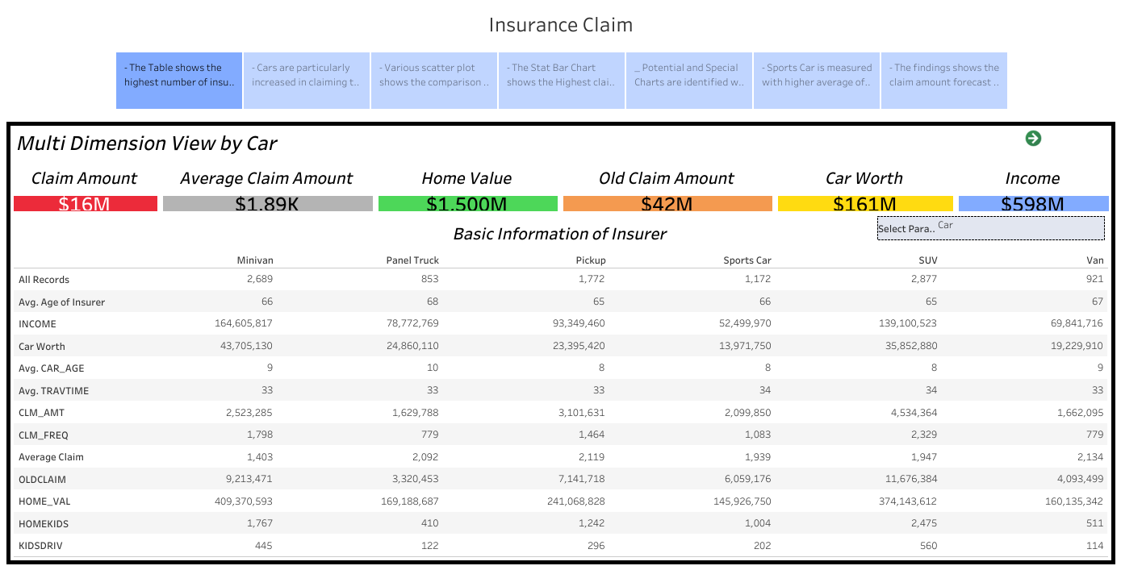

- The Table shows the highest number of insurances is claimed by SUV users with total claim amount $1.3M. The lowest claim amount of $ 179K was made by Doctors and Blue collars contributing the highest claim of $ 4.7M. High School Grade qualification persons are making the highest claim of $ 5.4M and the lowest claim with PhD Holders. The overall highest claim of is made by Female when compared to Male.

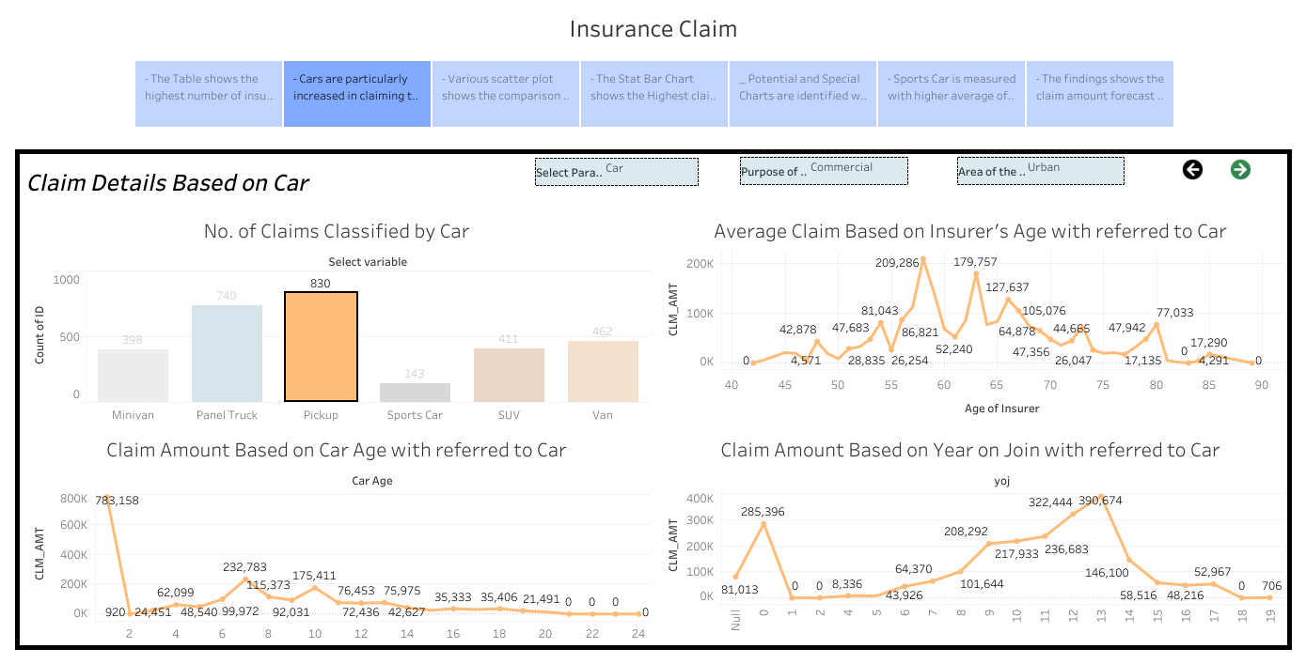

- Cars are particularly increased in claiming the insurance at 11th year and in initial year and showing seasonality of Insurance Claims. The claim made by SUV users in Urban Area is mainly for the Private Purpose and the Insurer Age at 65 is claiming more amount when compared to other age group. The claiming seasonality is measuring the same in occupation with highest claim Clerical designators. Whereas, the highest claim by Lawyers are showing slight seasonality. In initial purchase of the cars, the insurance claims are high. Mostly the insurer is between 55 to 70 years old and the patterns shows the certain seasonality in the year of join from 8 to 16 years. In Rural Area, the insurance is claimed mostly by Clerical and with most SUV users for private use. In commercial purpose of car user the highest insurance made by Blue Collar Professional and highest claims by Pickup vehicles in Urban Area.

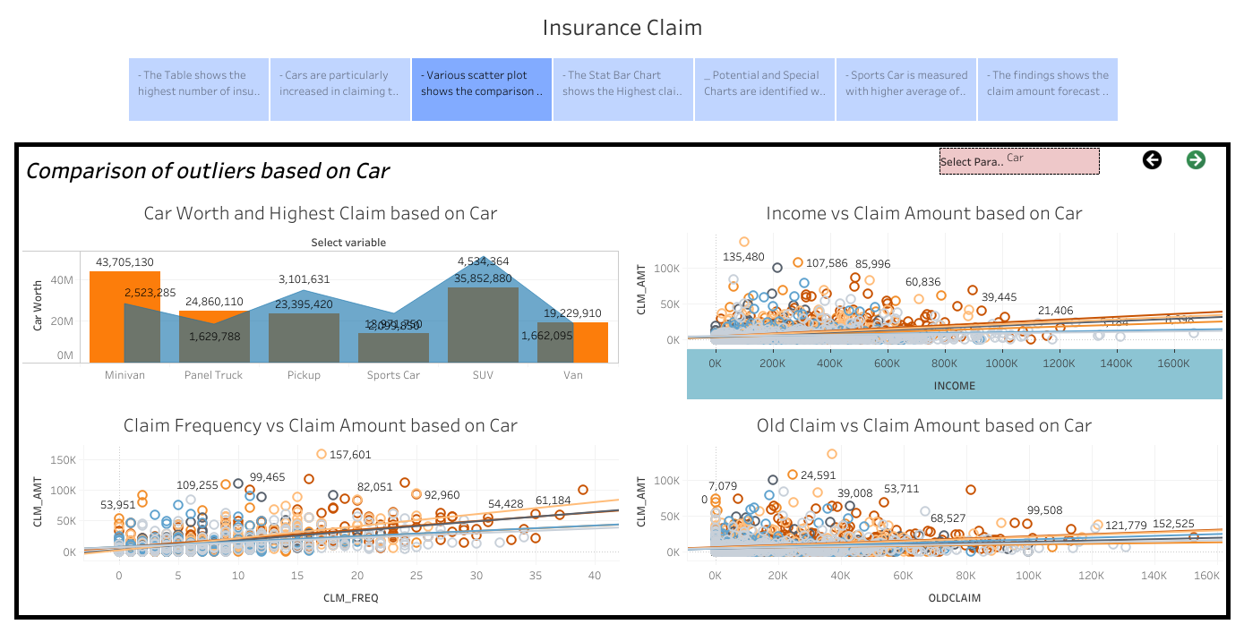

- Various scatter plot shows the comparison of Claim Amount and Income, Claim Frequency and Claim Amount, Old Claim and New Claim Amount. Cluster of Old Claim and New claim is mostly between 0 to 50K which shows the higher correlation. The highest claim is mostly at higher claim frequency and very low at claim frequency between 0 to 10 times but with more clusters. The Highest Income is making the lesser claim amount as the group are mostly around 0 to 1.4M. When comapring the car worth and Claim Amount, SUV cars are higher in claim amount of $ 4.5M while the Car Worth of the SUV cars is about $ 3.5M. and Minivan cars with claim amount of $ 2.5M with the Car worth of $ 4.3M as the chart explains the minivan users are less in Claiming the insurance and not frequently. The highest claim is made by Blue Collar Job people else the car worth is very low. The highest claim by Blue Collar Job People are earning the income around 500K and their frequency of claiming insurance are between 1 to 5 times and their old claim more grouped at average of 20K. The reference lines are measured in Trend Values where the R values are mostly correlated in all cases and shows similar effect by Increased Income Decreased Claim Amount and Increased Frequency of Insurance claim with Decreased Claim Amount and Lower Older Claim with Lower New Claim amount. Bachelor Degree Holders are measured with highest income and lowest claim and only having the lesser new claim amount.

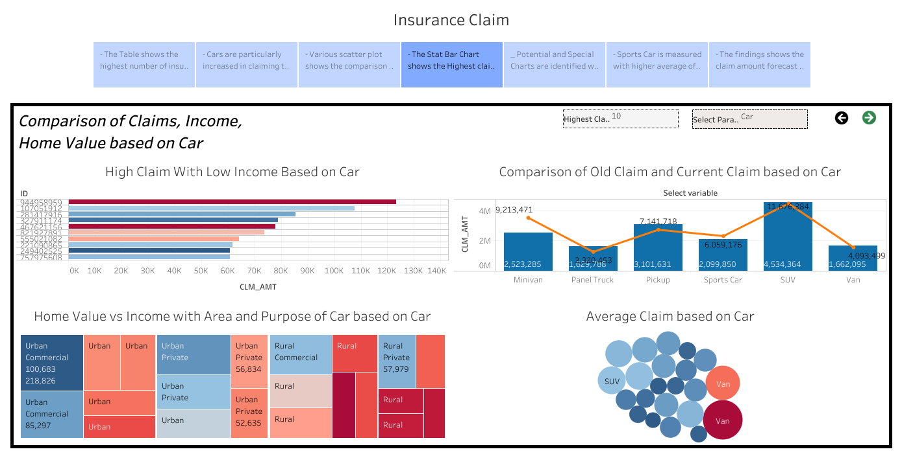

- The Stat Bar Chart shows the Highest claim with Low Income. the Top Claim is taken by the less Income ID and other ID are very linked to the appropriate claim. The second place of the highest claim is earning the moderate income. When Comparing Old claim and New claim is identified in SUV cars that old claim is higher and lower new claim and it follows the same inference for Minivan Cars and Sports Car. The Lower Old Claim and Lower New Claim is measured in Doctor Professional and maximum is measured with Blue Collar Professionals. Whereas, the High School Grade people are measured with higher old claim and higher new claim but the older claim are higher in Education category when compared with New Claim Amount. Whereas, the Highest Average of Home Value and Income is measured in Urban area for commercial purpose and low average of home value is measured with Rural area for private users. The Tree Map is diversified by the area and purpose of the car, where the private usage of car in Rural area is measured with low average home value and low average income. Where it shows the chance of highest claim. Sports Car users for Private usage in rural area is measured with less income and SUV users for commercial purpose in rural are measured with less average home value and the higher home value with higher income is measured for Panel Truck in commercial purpose in Urban Area. Bubble Chart explains the highest claim is in Urban Area for commercial purpose by Van car users.

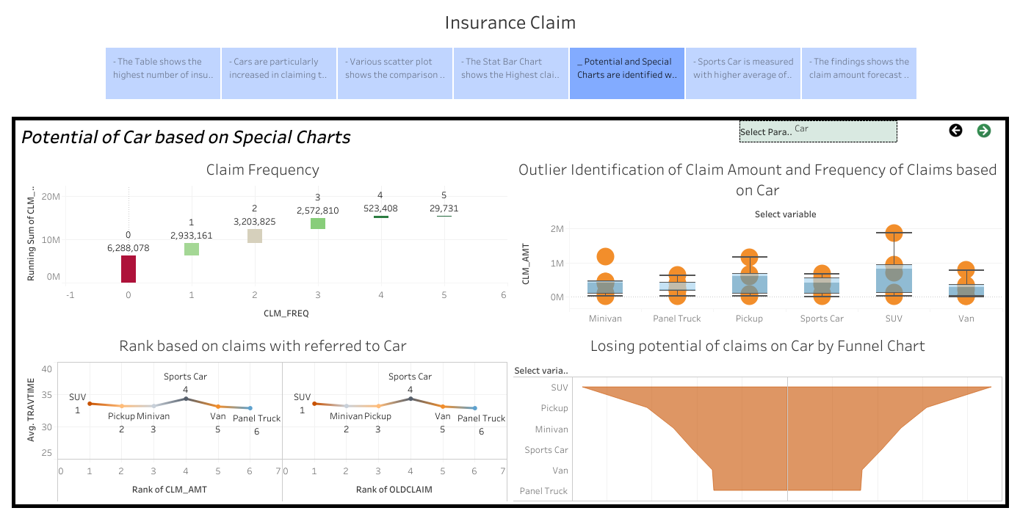

- Potential and Special Charts are identified with Outliers, Claim Frequency values, Rank of the variables and the potential of variables. The claim frequency shows that the initial stage of the insurance filed is getting higher claim of $0M to $12M and the highest frequency 5 times is measured with the claim of $15M to $16M which is measured of $1M total. The moderate claim amount is measured with the 1 and 2 frequency of the car registered for the insurance. The Boxplot shows the highest outlier is identified in SUV cars and it placed the 1st rank in claim amount in respondence to Travel Time. In Rank order the claim amount for the Pickup cars users is increased in New claim when compared to the old claim by the insurers. In occupation category, the Blue Collar professional are measured with highest outlier and when comparing the Rank of the Occupation, Lawyer, Home Maker are making higher claim whereas the Manager rank is showing the highest increased from 4th to 8th rank in new claim. The Funnel chart shows the decreased area from Blue Collar to Doctor and measure the same as rank of the new claim amount. High School Grade people are measured for the 1st rank in claiming amount and same with higher outliers.

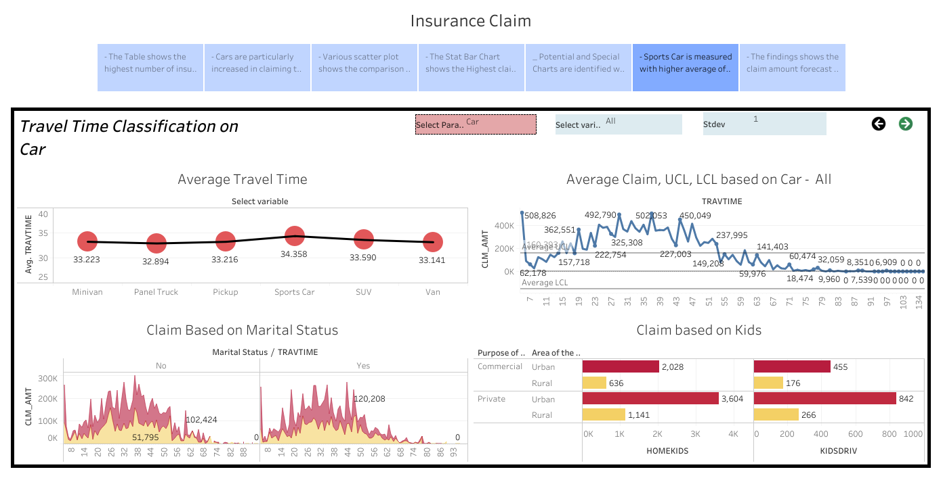

- Sports Car is measured with higher average of travel time of 34 Minutes and the std. deviation 1 which describes the Upper control limit and lower control limit. The control lines are referred with the maximum highest average claim based on travel time. The travel time for 54 minutes is measured for the highest Average claim and the lowest claim are measured over 66 Minutes. The Marital Status shows the same percentage on number of insurer with same pattern. This shows the 50% accuracy in both private and commercial purpose of the car. The Rural and Urban area are measured for travel time. The Kids in Home and Kids with Driver is measured with the insurance claims for the private use of car with maximum kids and it shows the maximum of the Urban area is with maximum number of kids in home as well as in Driving Car also.

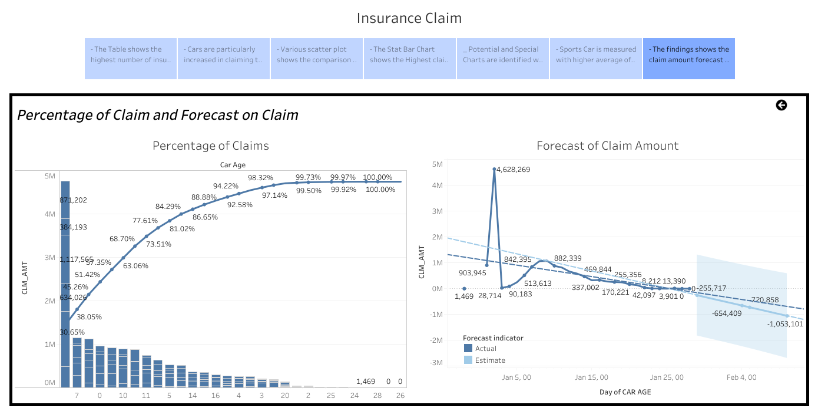

- The findings show the claim amount forecast based on Car Age of the insurer. The forecasted value shows that claim is not possible or claim cannot be done on higher car age and the confidence level is very low to procure the insurance for the older cars. Percentage of claims is measured for the increased frequency in Car Age. The claim is measured for the initial stage of the claims and the measured value is initiated by 30%.